Report on the ICSS project
Motivation / Context: (Description of the task/problem, and why this development should be done.)
Politicians get paid too much, get too much power to be so lightly supervised by the population, this is an attempt to keep putting some pressure on them.
Population don’t have, understandably, a good grasp on how the politicians argue in the chambers, and watching the videos of the discussion can be a very long task.
One way of making democracy work is to be able to have check on it, the electors and the public should be able to get a better understanding of what’s being said.
Of course, this is not all and not only people can lie in their words, they can also honestly have cognitive dissonance on what they do.
Transparency
What Biblioteca Nacional del Congreso is?
How many deputies, election periods

Design
Approach to developing the project.
This project was developed as the continuation of a project I worked on before, the closing work for a “Data Science for Public Policy” diploma (2021). Me and some classmates worked on some basic analysis on the transcription of just one discussion of law (without any web scraping, the pipeline needed us to upload the pdf version of the discussion), this was done in the R language. With the previous mentioned motivation, I decided to go back to the previous work, to apply the new Python knowledge and to make the scale a little bit bigger.
The project consists on 5 notebooks (.ipynb): 2 for scrapping “get_deputies” and “get_laws”, 1 for cleaning (“clean_speech”), 1 for matching (“matching”), 1 to learn and create the analysis methods (“analysis_suite”) and one final .py file for the dashboard (“dashboard”).
[Screenshot of the folder structure]
This organization is how I conceived the pipeline of the project, first to obtain the important information on the deputies from XXX page, create a SQLite database (“Chilean_polispeech”) and upload the relevant information for the project, to this database is where the subsequent steps will upload the relevant information collected,
Deputies table
If None in XXX then Continue/None, things that I leave for the future but where not necessary for now. This is something that I stopped doing later (not having .dropna() when it wasn’t strictly necessary)
The political territorial information of the deputies (Region, District and Comunes) came from another API because the initial one was a mess. It brought the problem that it comes from “active deputies” which is not true because it still shows as active deputies people that weren’t elected again, but for now 21.03 is still the way to get the infromation

__
then to proceed scrapping the discussion of law and it’s most relevant information for this project, also to upload to

The BCN server, when clicked on "Show full document" ("Ver documento completo") to see the whole transcription of a discussion send a xajax request specifying what the user wants to see, as response the user get a response composed by 4 JavaScript commands, the second one contains the transcription that will be loaded into an overlay ('.modal-body' from Bootstrap). The goal of the following function is to obtain the transcription simulating the request that would be done from the browser from a user
“injects the transcript HTML into $('.modal-body').“
Run the whole extraction pipeline for one law, the steps are:
1. open a session
2. download the page and get the metadata
3. create the law folder
4. discover all discussion entries
5. filter to the target ones
6. fetch each target transcript and save it
7. return a list of summary rows to be added to the global summary CSV

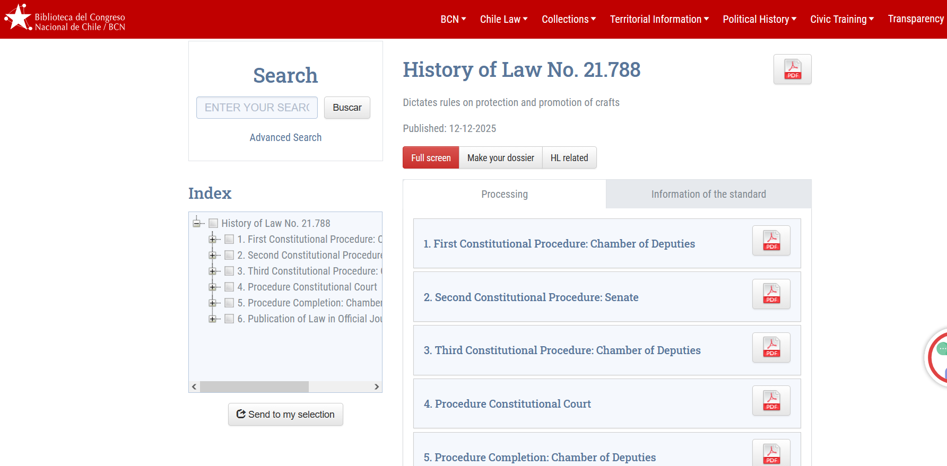
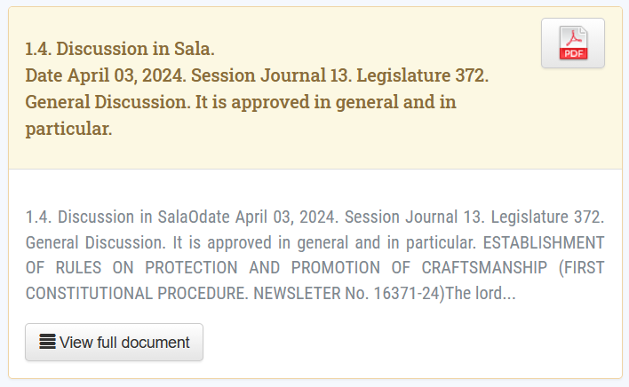

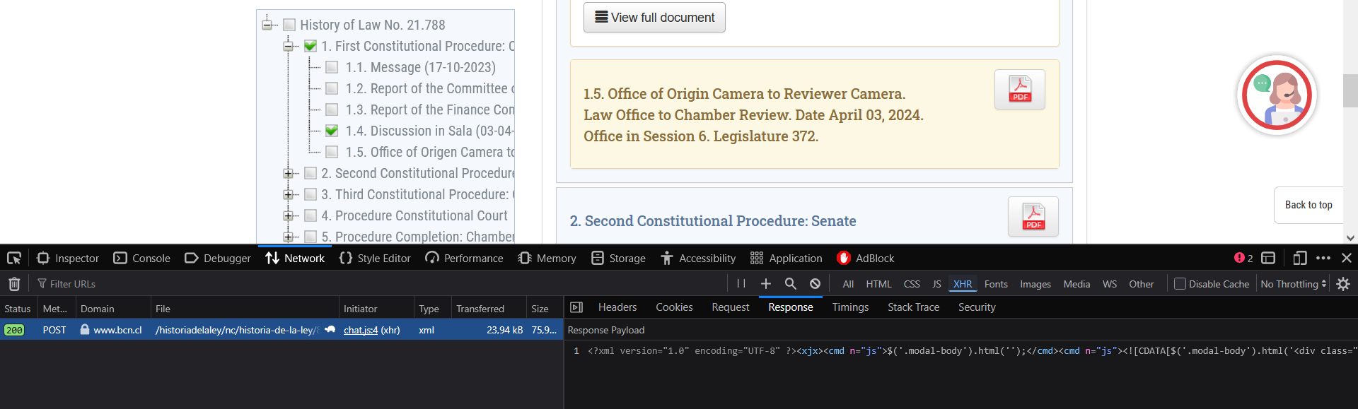

Cleaning
3 categories I see (for this is necessary to separate the speeches first and then to do a progress of categorization)
* *meta information*
I have to discover everything that its more metainformation on the session (date, session numbers, type of discussion, election results and process).

* *Substantive / political speech*
Also the speeches by the deputies.
They start with the president introducing them, then they start and this is always a new parragraph, also their names appear with a (el/la señor*) start of a parragraph

* *floor control*
There's also the comments made that are about the organization of the chamber itself, comments mainly from the "mesa directiva" to control the floor, talk about rules, closing the speech of people that spoke too long, ask for silence, calling for elections

What information is being collected
For deputies
[Screenshot of the sql database]
Break it down to tasks, their relationship and the overall structure of the software.
Make a diagram or figure
Description of the project

Some files that I created during the process (like storing the call DiputadosXPeriodo) are transformed into comments and moved to a exploratory appendix at the end of the notebooks

Innovation:
What’s new, what’s learned. It is graded as the level of learning, not the level of innovation.
Show what’s mine and what’s work from others

Results:
Illustrate outcomes or findings. If I start saying that it’s not conclusive information and based on a smaller corpus I can show what I see, not how it is.

Outlook:
Challenges, issues
Further ideas building on the project
A tool like this also allows for an eventual study of the language patterns, how does the linguistic landscape changes when X party appears on the scene.

Law extraction, laws that were published before jun 2022 had more often discussion of previous political periods, later that December 2025 didn’t had always the updated and final discussion
Is preprocessing deterministic?
The code itself will vary now because of the change in the political chamber of deputies in Chile, turn to extreme right wing
Challenge of the cleaning of discussions transcriptions: the processing has to consider two levels, first just separating each participation in terms of who’s speaking. Then to do a classification on: is this person a deputy? Is this a political speech or is it just manifestation, rules or interruptions?
Recognise also influence by AntConc

Development of the project
In the Analysis I have been developing initial functions that were strict on what they allowed, in the last iteration I gave more space for the user to search for what they want (here also, AntConc)
SQL was thought to be for a scaled up version of the project

Challenges and what I learned:
I haven’t done a project like this before, I didn’t knew how to organize the folders, notebooks, how to create an app in this sense. This made me study a lot extra on how people create this kind of projects and how to maintain them in an organized way. Also about more style guidelines, like using all-caps for constant configuration variables
About coding conventions, using ALL CAPS on configuration constants, to separate from regular variables
What is computed live and what not (output precomputed?)
Webscrap, vpn and bot limits
Importance of store extra information. HTML, json and text
Working with copies
Working with AI as a tutor, turbo learning but having to develop guardrails to protect my knowledge and limit the development not to what I can think of, more to what I can do and understand (which is less than what I can think of)
Limit of what I really know about NLP
Problem with militancies, how I stored the .db database and “The militancy table contained historical party affiliations across legislative periods. To avoid duplicate matches when linking speeches to party affiliation, the analysis restricted affiliations to those beginning in the 2022–2026 legislative term and matched speeches to the affiliation active on the discussion date.”
In the search regex can mess things up
Future development
Switcher deputies, it requires more work, but it is fully doable. But then it was necessary to add the data. I left still part of the code in the notebooks with the aim of proceeding in the future. For now we are working with the last known party for the deputies
Allow user to introduce personalized stopwords, because depending the law it can be different for each topic, but at the same time show the number of introduced custom stopwords, so people can’t cherry pick and have the results they want to prove a point without having some grounding truth
Word in context
To cluster by law topic
I don’t need new more complex functions, work with what we had, even if you give me the same code of before, I will have to explain each line of code in the end, so I need explanations and simple code

Results:
Nan, deputies that were written wrong, dona Jaime Araya, Gúzman vs Guzmán and Sigurdía vs Sigurdia. Araya was fixed by hand, then I stopped because it is part of the file itself. I added a dropna() to fix it also
The value of None as a security

https://regex101.com/

